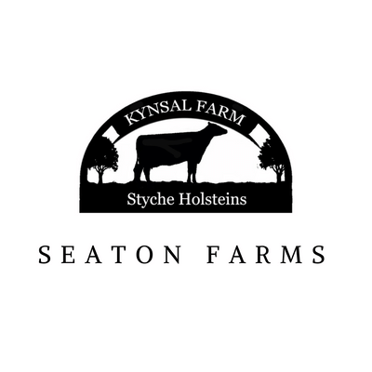

Information for Visitors

On the day of your visit, you will be met by Kelly and/or Jeanette who will give a brief overview of the farm, safety information and locations of facilities. This will also allow time for visitors to get togged up into suitable attire if required.

We will then enter our first activity. Under the assumption arrival will be around 10am, a short farm tour to the parlour which won’t be in operation at this time, to see the cows in their housing followed by our first activity at around 11am. We usually aim to make the first activity a messy one, ideally in soil if we are able to!

We then aim for a break around 12:00 noon for hand washing and lunch to take place. Ideally this should last no more than 30 mins

After lunch we like to allow time to be free and burn off some energy before, we come back to a more mindful activity. This should be finished by 1:30pm where, if appropriate another opportunity for hand washing and a refreshment break will take place followed by a trip to the parlour to see milking taking place.

We are also able to do any writing activities at this point before assumed departure at approx. 2pm

Of course, timings can be subject to change depending of weather and travel arrangements but this is an example of a day on the farm.

**Milking times are 05:00 – 08:00, 13:00-16:30 & 20:00-22:30**

**Calf Feeding times are 08:00 & 15:00**

**Our cows calve (have babies) all year round so there is always a newborn to see and often a cow calving too if you’re lucky!**

A map of the main yard is below with a brief outline of locations. All yellow areas are cattle housing. The pink outline depicts the parlour and red is the slurry lagoon. Please note there are many hazards on a farm but the slurry lagoon is of particular danger and as such must be avoided!

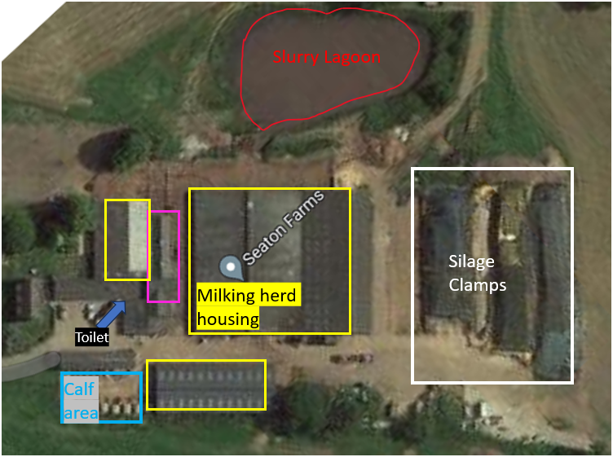

A map of the larger farm area is below:

The farm is located on the Shropshire Cheshire border with the Shropshire Union Canal running through the land. The main route to the farm is marked in yellow from A529 (Market Drayton to Audlem road). The farm boundary is marked out in blue for an idea of where can be accessed. Suggested routes are marked out in pastel colours although may be subject to change depending on conditions and main target outcomes of your visit.

