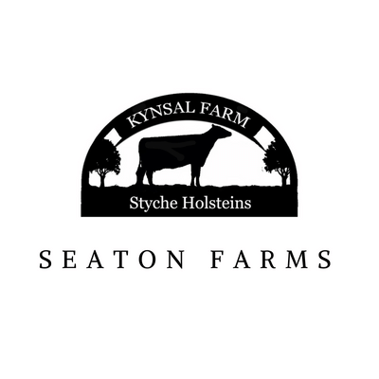

Conduct on the farm policy

We really enjoy having visitors to our farm and look forward to welcoming you to learn with us. To

ensure that all visitors have a fun and educational experience it is important to remember that the

Kynsal Farm is a working farm. Therefore, it is important that all visitors read

and understand the conduct on the farm policy. There is a risk in most activities, however, by following the simple steps below we can control hazards and risk of infection to make your visit as safe, healthy and enjoyable as possible.

Pupils and staff will be briefed on the important rules and information on arrival, however, it is also

recommended that these are shared prior to the visit to make sure that everyone gets the best

experience.

A pre-visit by the teacher conducting the planned visit to the farm is a requirement to assist in the planning process and allows an opportunity

to see the farm and discuss all aspects of the visit.

It is essential that schools meet the required “staff to pupil ratio” and bring at least one trained first

aider and a first aid kit as well as any medication required by individual children (for example inhalers).

• All visitors should wear outdoor activity wear, appropriate to the weather conditions. No school

uniforms please.

• Wellies or boots are the most suitable footwear, especially in the winter months.

• A carrier bag for taking home soiled clothes is also required

• Gloves should not be worn on the farm due to risk of contamination.

• Any cuts, grazes etc on children’s hands must be covered with a waterproof dressing.

• All pupils must follow the instructions and directions given by the deliverer. The

deliverer knows the route around the farm and will follow the safest route. This may be subject to change depending on current farm activities so the deliverer may make changes to the originally planned route in line with safety measures.

• Groups must stay together. Farm staff will advise of the meeting point in case of anyone getting

separated from the group.

• If the deliverer calls ‘STOP’ or blows a whistle everyone must stop still and await further

instruction. Again, this is precautionary and designed only to aid safety on the farm.

• Pupils should remember that farms are not playgrounds. Please view the farm as you would

think of a classroom at school.

• No running or shouting near the animals as its their home and it can spook them.

• Please be kind and gentle to our animals but don’t kiss the animals.

• Visitors should not pick up any tools, or touch work equipment unless permitted to by farm

staff. Farm staff will instruct on the safe use of any equipment.

• To prevent injury or falls, please do not climb on fences, gates or animal pens.

• Look after the farm and any equipment used.

• To minimise the risk of transmission of disease, please only eat and drink in the designated

areas and after thoroughly washing your hands. Children may need to be supervised in doing

this. Farm staff will support with this and provide plenty of time.

• There will be lots of hand washing. This is especially important after touching any animals,

after visiting the toilet and before eating or drinking. Hand gels and wipes are not a suitable

alternative. You will also wash your hands and footwear before leaving the site.

• Listen well and ask lots of questions!

• Have the best time!

• Kynsal Farm will follow guidance in “Industry Code of Practice –

Preventing and Controlling Ill Health from Animal Contact at Visitor Attractions Industry Code

of Practice 2021 and the How to plan curriculum linked and safe visits to farm: A Handbook

from Teacher by LEAF. Both of these documents are available for download at

https://www.farmeducationcentre.co.uk/documents/

• The farm is a no smoking area and as such smoking (including vaping and e-cigarettes) is not

permitted on the farm.

We hope that you agree that these rules are common sense and will allow everyone to have an enjoyable

experience. If you have any questions, please ask.

Signed

Kelly Seaton

01/01/2024